**7) How to create table calculations in tableau with examples . (With the help of an example**

**create one in tableau)**

Table calculations in Tableau allow you to perform calculations on the result set of your visualization. These calculations are often used to analyze data in a way that goes beyond the standard aggregations provided by Tableau. Table calculations operate on the data that is currently being visualized, considering the table layout and the structure of the view. Here are the steps to create table calculations in Tableau, along with examples:

**Steps to Create Table Calculations:**

**Step 1: Build Your Visualization:**

* Create a worksheet and build a visualization using the necessary dimensions and measures.

**Step 2: Apply Table Calculation:**

* Right-click on the measure in the view for which you want to apply the table calculation.
* Hover over the "Quick Table Calculation" option.

**Step 3: Choose Calculation Type:**

* Select the specific calculation type you want to apply. Examples include running total, percent of total, moving average, etc.

**Step 4: Configure Calculation Settings:**

* After selecting the calculation type, you may need to configure additional settings based on the specific calculation.

**Step 5: Adjust Compute Using:**

* Right-click on the pill in the view that represents the calculation and select "Compute Using" to specify the scope of the calculation. This determines how the calculation is applied relative to the visualization's structure.

**Step 6: Example of Running Total:**

* Suppose you have a line chart showing monthly sales. To create a running total, right-click on the sales measure, go to "Quick Table Calculation," and select "Running Total."

**Step 7: Example of Percent of Total:**

* If you want to show each month's sales as a percentage of the total sales, right-click on the sales measure, go to "Quick Table Calculation," and select "Percent of Total."

**Step 8: Example of Moving Average:**

* For a moving average of sales over a specific period, right-click on the sales measure, go to "Quick Table Calculation," and select "Moving Average." Configure the settings, such as the number of periods to consider.

**Step 9: Adjust Compute Using for Partitioning:**

* When using table calculations that involve partitioning (like running total by a specific dimension), adjust the "Compute Using" settings to specify the partitioning dimension.

**Step 10: Explore Other Calculation Types:**

Tableau offers various calculation types, including rank, percentiles, difference from, and more. Experiment with different types to find the one that suits your analysis.

**In Tableau:**

**Prerequisites**: Superstore Data-source provided by Tableau, which includes three tables: orders, people, and returns.

**Orders Table**:

Columns: Order ID, Order Date, Ship Date, Ship Mode, Customer Name, Segment, Country/Region, City, State, Province, Category

**People Table**:

Columns: Regional Manager

**Returns Table**:

Columns: Returned

* For any sheet click on measure then go to quick table calculation and select the type of calculation.
* For this instance, I’m selecting Percent of total.

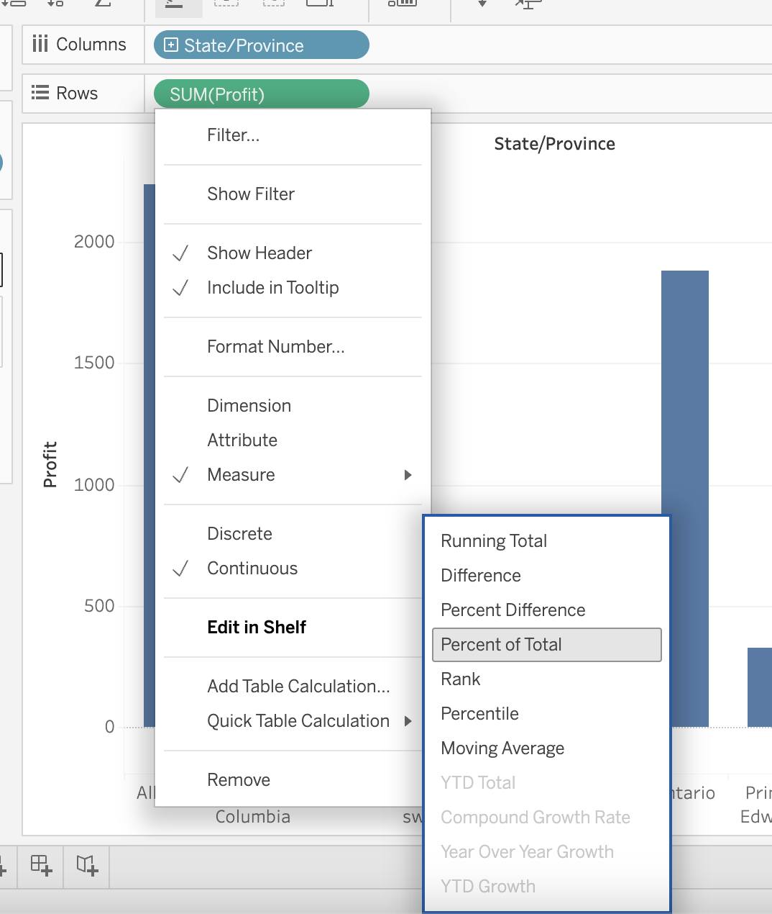

* Then we can see the % per cent share of each State as shown below.

